17.119: a) At steady state, the input power all goes into heating the water, so 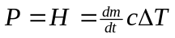 and
and the output temperature is 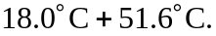 b) At steady state, the apparatus will neither remove heat from nor add heat to the water.

